Project Proposal

Credit Card Fraud Detection Project

Author: Dhrubajyoti Ghosh

Contents

Brief on the Project 3
Dataset Features 4
Deliverables of the project 5
Model Selection 11
QnA 12
Model Information 13
Important Findings 13
Resources & Individual Details 14
Milestones 15

Brief on the Project
The purpose of this project is to develop a machine learning or deep learning model capable of detecting fraudulent credit card transactions. This will help credit card companies to identify suspicious and unauthorised transactions early, reducing financial losses and protecting customers from fraudulent purchases.
The proposed fraud detection system will provide the following benefits:
- Fraud detection: Based on historical data, it will identify suspicious transactions and unusual customer spending and behavioural patterns.
- Reduce financial losses: Minimize financial losses for both customers and credit card companies by detecting and preventing fraudulent transactions promptly.
- Enhance customer security: Strengthen the security of credit card transactions by reducing the risk of unauthorised activity and financial fraud.
- Build customer trust: Builds confidence in customers about the safety and reliability of credit card services provided by the companies. They can feel assured that their financial transactions are protected.
The credit card fraud detection model will be developed through a comprehensive analysis of the available dataset. The dataset consists credit card transactions made by European card holders in September 2013. To protect user privacy and confidentiality, the original features and background information is hidden. The numerical features in the dataset are obtained through Principal Component Analysis (PCA) transformation on original dataset. The dataset will be used to train and evaluate a classification model that will predict fraudulent transaction based on this PCA transformed features.

Dataset Features
The dataset comprises 30 independent features and one dependent feature. Among the 30 independent features, 28 are PCA transformed features while remaining 2 are original untransformed features. Each record/row represents an individual credit card transaction.
The critical parameters of the dataset are as follows:
- Features V1 to V28: These features represent the principal components obtained with PCA on the original features. This is done to protect the privacy of the customers by hiding the original feature information.
- Time: This feature is not transformed through PCA. It indicates the amount of time elapsed in seconds, between a particular transaction and the first transaction in the dataset.
- Amount: Another feature not transformed through PCA. It indicates the amount transacted through credit card during each transaction.
- Class: This is the dependent feature. It consists of 2 values 0 and 1. 1 indicates fraudulent transaction and 0 indicates otherwise.
The dataset represents credit card transactions recorded over a period of 2 days in September 2013 in Europe. There are only 492 fraudulent transactions among 284,807 transactions. This indicates the dataset is highly unbalanced. Fraudulent transaction accounts for only 0.172% of all transactions. Among these transactions, 1081 are duplicate transactions. Among these duplicate transactions, 32 transactions fall under fraudulent category. Final, figures used for training and testing is shared below.
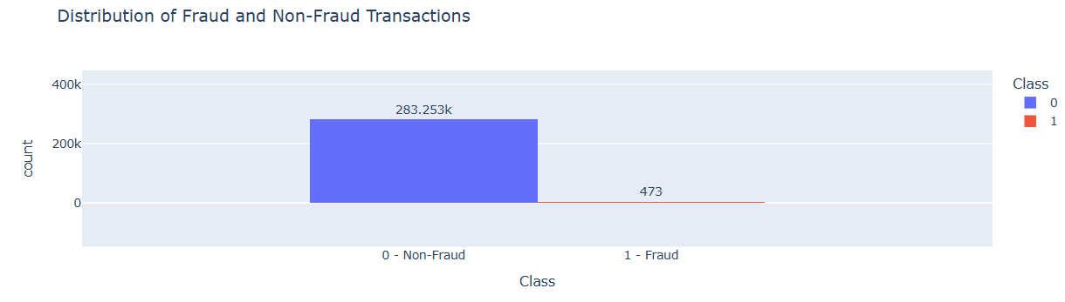

Deliverables of the project
- Jupyter Notebook: It contains the python code that does the following:
  - Imports and analyses the dataset.
  - Transforms the data to remove anomalies or inconsistencies.
  - Splits the data into training and testing dataset.
  - Scales the data to fit into machine learning or deep learning model.
  - Compares performance of various machine learning or deep learning algorithms against the training and testing data and identifies the best model.
- Pickle Files: The identified best model and subsequent transformations are exported through the pickle files. The project has the following pickle files:
  - Power Transformer Pickle File: Used to remove skewness of the dataset.
  - Scaler Transformer Pickle File: Feature scaling technique used to standardise the dataset.
  - Model Pickle File: Contains selected Machine Learning Model. Though the model has high accuracy yet it has not been finalised due to various reason specified later. Instead, deep learning model is used.
  - Label Encoder Pickle File: This file is not required as all features including dependent feature are already represented through numerical values. Hence, no label encoding is necessary.
- Deep Learning Model File (.keras): The finalized deep learning model saved in Keras format.
- Front end Code: It does the following:
  - Imports the Pickles Files mentioned above.
  - Uses Streamlit to design the front end that takes the independent features as input.
  - Transforms the input features using the various transformations imported through the pickle files.
  - Uses the imported machine learning or deep learning model and predicts if a transaction is fraudulent.
  - Displays the predicted result.
- Project Report File: A word document provides comprehensive overview of the project, outlining the approach used towards development of the machine learning or deep learning model. The various challenges encountered during the process and the key factors that influenced selection of the final model.
Approach Note
- After importing the basic libraries, the dataset is loaded into a dataframe.
- As the features are transformed through PCA, and column names seems consistent hence further modification of column names of the dataframe are not required. It remained unchanged.
- Summary about the dataframe is generated to see the structure and details of the dataframe.
- The dataframe was examined for duplicate records. There are 1081 duplicate transactions. Among these duplicate transactions, 32 transactions belong to fraudulent category. The duplicate records, especially the records classified as fraudulent are further are analysed. After analysis, all duplicate records are removed.
- After duplicate record removal, finally 283253 non-fraudulent and 473 fraudulent transactions used for training and testing.
- No such input features were identified that can be removed from the dataset as it has already been transformed through PCA. Moreover, the features are non-collinear with respect to fraud class due to PCA.
- As the dataset is highly imbalanced, hence following methods were selected to handle class imbalance:
  - Random Undersampling
  - Random Oversampling
  - Borderline-SMOTE + Undersampling
  - Borderline-SMOTE
- SMOTE-Tomek was not used to avoid unnecessary oversampling. It was making the dataset large through synthetic data impacting the performance of the Machine Learning and Deep Learning models. On the other hand, Borderline-SMOTE preserves potential informative boundary information. It emphasizes these samples rather than subsequently removing boundary observations. This is crucial in fraud detection scenarios.
- In PCA, the features are orthogonal with each other. Hence, Variance Inflation Factor (VIF) was not taken into account to remove correlated features. Below correlation heatmap indicates the same.
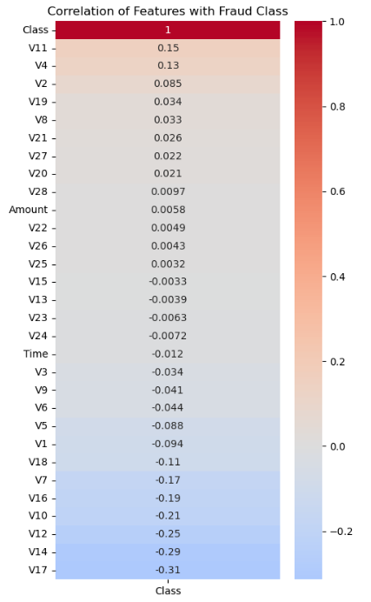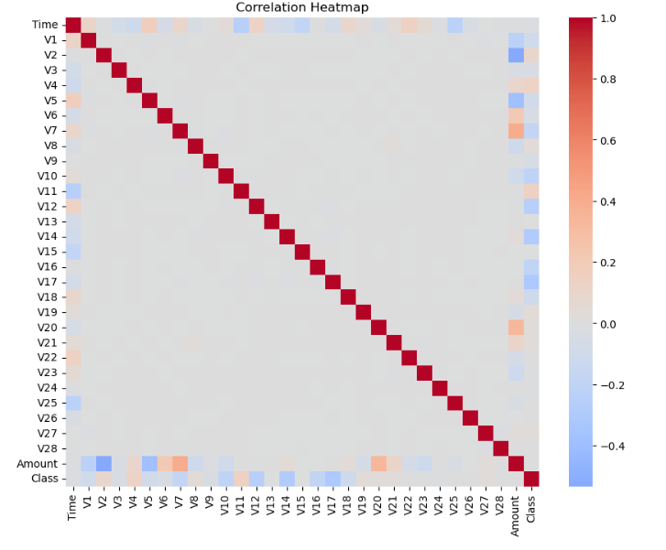
- The dataset was first divided into feature (X) and target (Y) variables, followed by a train–test split. Since the dataset is class-imbalanced, stratified sampling was applied based on the target variable to preserve the original class distribution in both the training and testing sets.
- The training data was resampled using the techniques to address class imbalance as mentioned in point 7.
- Then, skewness of the features in each of the four resampled datasets was identified and addressed Power Transformer. Subsequently, outliers were treated using the capping and flooring method. Finally, all four datasets were scaled using MinMaxScaler as all features consists of numerical values.
- Following Machine Learning Models were used for evaluation:
  - Logistic Regression
  - Decision Tree
  - Random Forest
  - K-Nearest Neighbors (KNN)
  - Support Vector Machine (SVM)
  - Naive Bayes
  - AdaBoost
  - Bagging
  - Gradient Boosting
  - XGBoost
- Later on, KNN, SVM, AdaBoost, Bagging and Gradient Boosting were discarded due to performance issues. And other models were already having very high accuracy figures.
- XGBoost on original dataset showed the highest accuracy and least difference between training and testing dataset.
- Machine Learning Models with the dataset balanced using Random Under-Sampling showed least accuracy with high difference between training and testing accuracy.
- The accuracies of machine learning models balanced using Borderline-SMOTE showed best accuracy figures. Then, we tried to hyperparameter tune the models using these datasets.
- Though Hyperparameter tuned XGBoost models trained on Borderline-SMOTE seemed to have comparable confusion matrix, yet Hyperparameter tuned XGBoost model have marginal lower testing accuracy. Also, Average precision (AP) and Area under the curve (AUC) is better in normal XGBoost model trained on Borderline-SMOTE dataset compared to any hyperparameter tuned models.
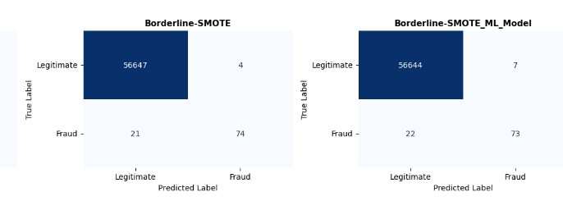
Left: Confusion matrix of Hyperparameter Tuned XGBoost Model trained on Borderline-SMOTE dataset.
Right: Confusion matrix of XGBoost Model trained on Borderline-SMOTE dataset.
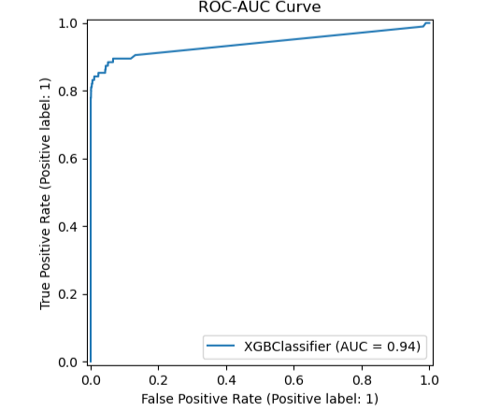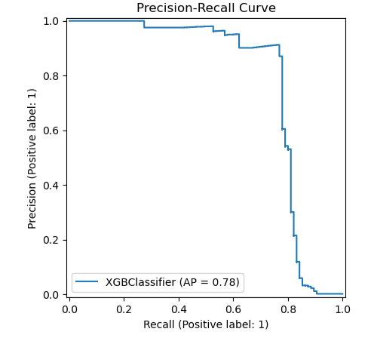
ROC-AUC Curve and Precision-Recall Curve of XGBoost ML Model
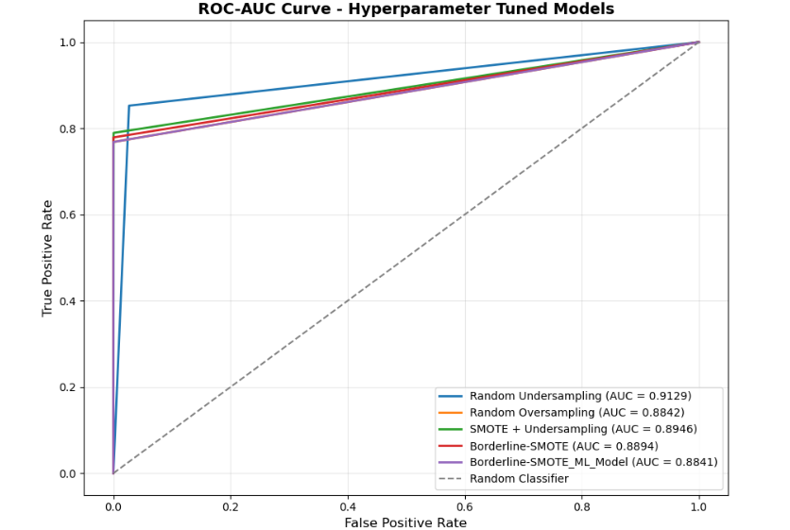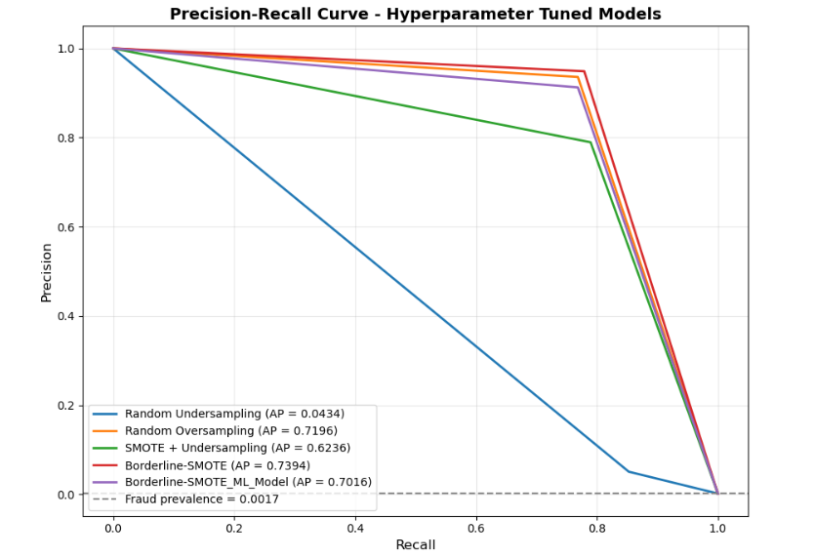
ROC-AUC Curve and Precision-Recall Curve of best hyperparameter tuned ML model
- Due to highly imbalanced nature of credit card transactions where fraudulent transactions represent only a small percentage, a Deep Learning Artificial Neural Network (ANN) model and a Keras tuned Deep Learning ANN model were developed to identify the complex patterns associated with fraudulent activities that may not be captured by conventional ML models.
- Both Deep Learning Artificial Neural Network (ANN) model and a Keras tuned Deep Learning ANN models were trained on all the 4 datasets mentioned in point 7. It was also decided, to avoid overcorrection of minority class, scale_pos_weight will not be used.
- Deep Learning ANN model trained on Borderline SMOTE dataset showed highest AP value in Precision Recall curve and its AUC value is comparable to deep learning models trained with other datasets. Also, its figures are better than Keras tuned models. It also has the best confusion matrix. Hence, this model is selected. Further, this model is also trained on balanced class weights.
- After finalising the model, the model and transformations like Power Transformer and Scaler transforms are converted to pickle file and exported. Also, the finalized ANN model is saved in Deep Learning Model File (.keras).
- The generated pickle files and Deep Learning Model File were imported into Visual Studio Code, where the project's front end was developed using Streamlit.
- In the front end, users provide values for the finalized input features. These inputs are then transformed using the corresponding imported pickle files.
- The transformed input data is passed to the trained machine learning model to generate the prediction.
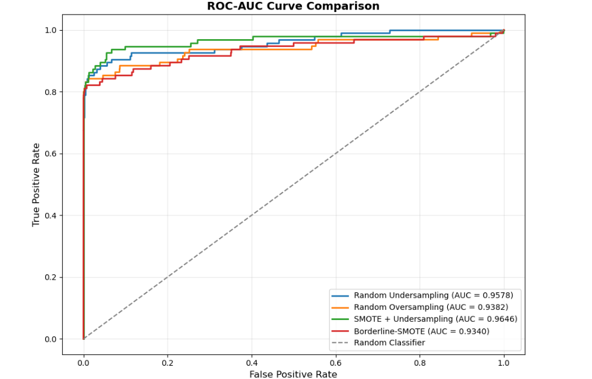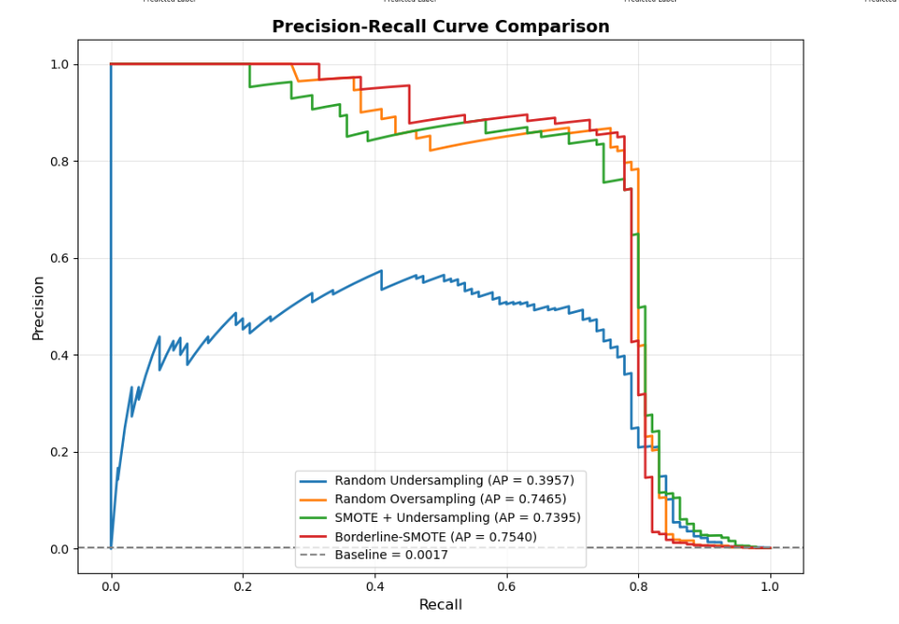

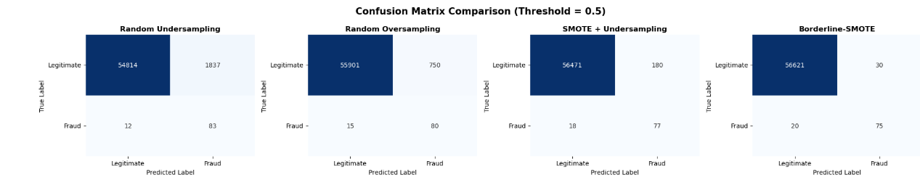
ROC AUC Curve, Precision Recall Curve and Confusion Matrix of ANN Model

Model Selection
Model | Actual: 0  Predicted: 0 | Actual: 0  Predicted: 1 | Actual: 1  Predicted: 0 | Actual: 1  Predicted: 1 | Test  Accuracy
Deep Learning ANN Model trained on Borderline SMOTE | 56621 | 30 | 20 | 75 | 99.945%
Keras Tuned Deep Learning ANN Model trained on Borderline SMOTE | 56611 | 40 | 44 | 51 | 99.852%
XGBoost Model trained on Borderline SMOTE | 56644 | 7 | 22 | 73 | 99.95%
Hyperparameter Tuned XGBoost Model trained on Borderline SMOTE | 56547 | 4 | 21 | 74 | 85%

Legends
0 | No Fraud
1 | Fraud

  - From the ROC-AUC curves, Precision Recall curves and confusion matrices of models trained on different dataset, it can be concluded Class imbalance handled through Borderline-SMOTE has best figures.
  - Deep Learning ANN Model trained on Borderline SMOTE and XGBoost Model trained on Borderline SMOTE shows almost similar and best figures. Hence, both the models are selected and saved. However, as ANN provides greater flexibility for learning complex nonlinear feature interactions, hence, it is finalised.

QnA
Q1. What are the mean, median, and mode of the transaction time for fraudulent transactions?
Ans: Please refer the below figures for details.
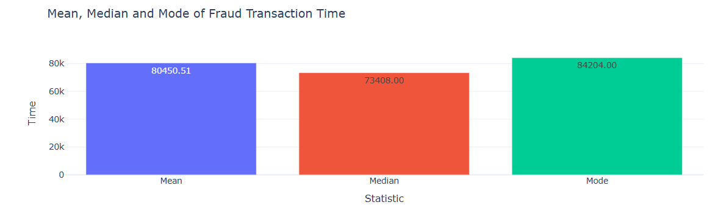
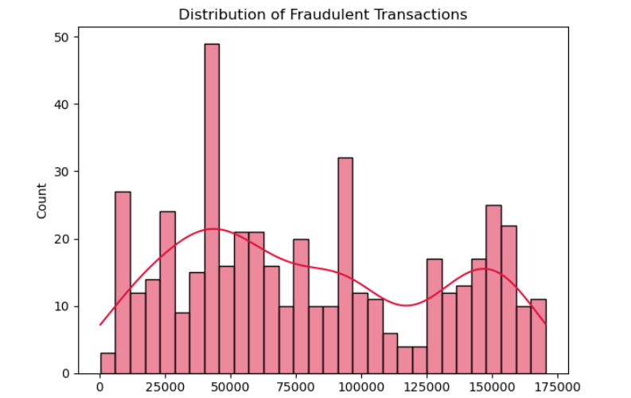
Q2. What are the mean, median, and mode of fraud transaction amount?
Ans: Please refer the below figures for details.
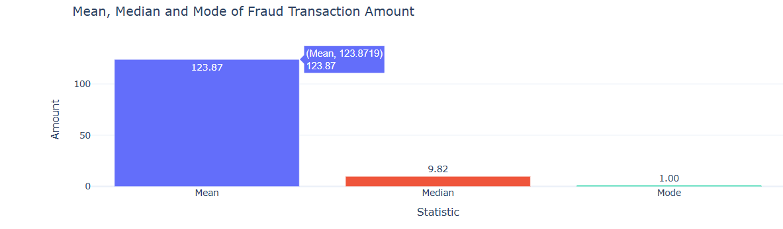

Model Information
Model Used: Deep Learning ANN Model trained on Borderline SMOTE
Method used to handle Class Imbalance: Borderline SMOTE
Method used to encode categorical data: Not Applicable
Transformer used to handle Skewness: Power Transformer
Feature Scaling technique used: MinMax Scaler
Python Version: 3.13
scikit-learn Version: 1.8.0

Important Findings
Deep Learning ANN Model trained on Borderline SMOTE exhibited a higher number of false negatives, meaning the model predicted fraudulent transaction when the transaction was non-fraudulent. However, this scenario will result in better prevention of unwanted transaction. Hence, this model has been adopted. Also, if we see the overall percentage, this figure is very low.
Sample Output
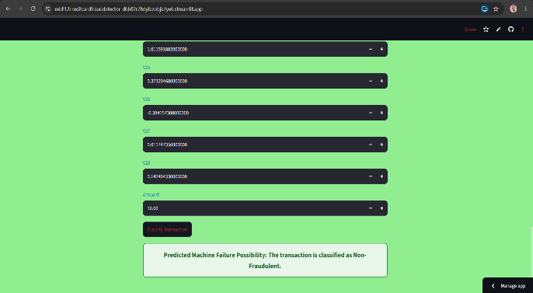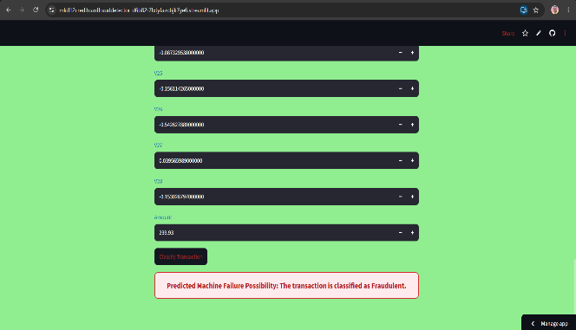
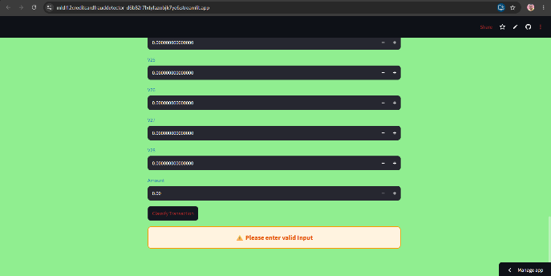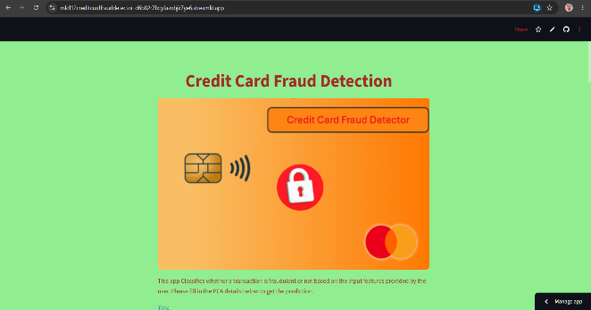

Resources & Individual Details
Data set source: The dataset has been downloaded from the portal. The data can be fetched through PCA transformation of actual data over time. It can be further used to train the model and improve its accuracy further.
Software: Jupyter Notebook, Visual Studio Code, Streamlit & GitHub
References:
- https://www.geeksforgeeks.org/
- ChatGPT
- Google Gemini
- Kaggle

Individual Details:
Name: Dhurbajyoti Ghosh
Email: <DND>
Phone Number: <DND>
*DND – information not shared for data privacy

Milestones
Define a problem | Develop an ML or DL model to identify a fraudulent credit card transaction.
Understanding the business problem | Business expects the ML or DL model to predict whether a credit card transaction is fraudulent.
Get the Data | Data shared in portal is loaded into Pandas Dataframe
Explore and pre-process data | The dataset contains 30 independent features and 1 dependent feature. Independent features include Time, Amount and 28 other features transformed from original data using Principal Component Analysis to protect user data. Dependent feature indicates if the transaction is fraudulent or legitimate.
Choosing the python platform | Python Version: 3.13  scikit-learn Version: 1.8.0
Create Features | Since the features are automatically transformed through PCA hence shared features are untransformed.
EDA | Dataset doesn’t contain any Blank (null) value. However, class imbalance has been identified that has been handled through Borderline SMOTE. Also, the duplicate values have been removed from the dataset after analysis.
Create Model | Following models are evaluated through cross validation and accuracy on various resampled dataset:  - Logistic Regression  - Decision Tree  - Random Forest  - Naive Bayes  - XGBoost  - DL ANN Model  - Keras Tuned ANN Model
Model Evaluation | Deep Learning ANN Model trained on Borderline SMOTE has been finalised due to high accuracy, better AUC ROC curve and better confusion matrix.
Report Writing | Report is uploaded on below link in GitHub:  GitHub Link
Project submission | Project GitHub Link: GitHub Link  Project Front End Link: Streamlit Link

